About
Trocaire College is a private Catholic junior college in Buffalo, New York, United States. Founded in 1958 by the Sisters of Mercy, Trocaire College offers certificate, associate's degree, and bachelor's degree programs in healthcare, business, and technology. It focuses on offering career-oriented programs in growing fields. The college is home to the oldest private Associate's Degree in Nursing program in western New York. It has an extension site in Williamsville, New York. Total enrollment across both locations is approximately 1,000 students.

Former Client Information
Trocaire is a former Sally and Amanda client that declined to renew their contract for $9k a month, 4 grants per year, at the end of August 2023. Amanda and Sally’s last correspondence with Trocaire was essentially – “maybe we'll re-engage” but then sort of just ghosted Sally with a "not now" type thing. Amanda was the D/MD on Trocaire for the full 6+ years working together. Amanda thinks they’d be tough and isn’t sure SI would be their thing. Trocaire also had their own lobbyist, so GR/earmarks didn’t have much appeal or value at the time.
We submitted projects for Trocaire every year from November 2015 until May 2023. Our final project with Trocaire was a Post-Award that they really liked, however they felt we had tapped all the faculty – they are unionized, off summers, and compensated for anything extra like working on grants. Their proposed merger with another one of our clients fell through (Medaille University, closed after COVID pandemic enrollment decline).
First Contract Start Date: 9/1/2015
First Contract End Date 8/31/2017
Last Contract End Date: 8/31/2023
Number of Contract Renewals: 3

Endowment and Financials
Endowment: $33.5 million FY23
Revenue: $20.1 million FY25
Expenses: $22.4 million FY25
Net Revenue: -$2.3 million FY25
Net Assets: $49.3 million FY25
Source: ProPublica NonProfit Explorer, Institution’s IRS Form 990

2025 Carnegie Classification
Private
Institutional Classification: Special Focus: Nursing
Highest Degree Awarded: Bachelor’s
Student Access and Earnings Classification: Opportunity Colleges and Universities-Higher Access, Higher Earnings
Size and Campus Setting: Small, mostly part-time, not residential
Historical Classification: Special Focus Four-Year: Other Health Professions Schools

Lobbying Disclosures
No lobbying disclosures.

Memberships
- ACCU
- CIC

Religious Affiliation
Roman Catholic

Designation
Special focus institutions, other than faith-related

HERD Ranking and Research Expenditures
Not HERD ranked.

Key Leaders

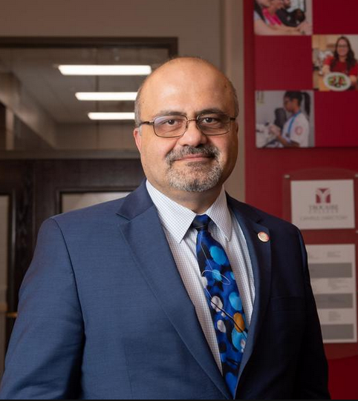
Bassam Deeb, Ph.D.
President
Note from Amanda:
- Bassam is a no BSer, shoot straighter, direct and quick usually in meetings etc. He churned through a lot of senior level folks so Sally and I always liked him well but am not sure he was easy to work for.
Trocaire College President Dr. Bassam Deeb has worked in the higher education realm all over the country for more than 30 years, primarily in leadership roles within the Student Affairs and Enrollment Management functions.
Originally from Lebanon, Dr. Deeb resettled in Buffalo with his family while he was a teenager, and he graduated from Hutchinson-Central Technical High School. Working as a peer adviser as a student at SUNY University at Buffalo helped inspire his path into a higher education career.
A member of the Western New York Consortium for Higher Education and the board of directors for the Association of Catholic Colleges and Universities and the Conference for Mercy Higher Education, Dr. Deeb is well versed in areas such as student services, higher education trends, healthcare and career-focused education and non-traditional student populations.
Connect with Dr. Deeb on LinkedIn
Professional Experience
President
Trocaire College, Buffalo, NY, 2012-present
Vice President for Student Services
Niagara County Community College (NCCC), Sanborn, NY 2004-2012
- Interim Vice President for Academic Affairs
June 2008-January 2009
- Executive Director, Student Housing Village Corporation
2006- 2009
Vice President for Student Affairs
West Liberty State University, West Liberty, WV, 2001-2004
Executive Director for Enrollment Management
Youngstown State University, Youngstown, OH, 1997-2001
Executive Director for Student Life
Youngstown State University, Youngstown, OH, 1995-1997
Interim Director, Special Student Services
Youngstown State University, Youngstown, OH, 1994-1995
Associate to the Vice President for Student Affairs, Assistant to the Vice President for Student Affairs
Youngstown State University, Youngstown, OH, 1988-1994
Director, New Student Advising and Retention
Briar Cliff University, Sioux City, IA, 1986-1988

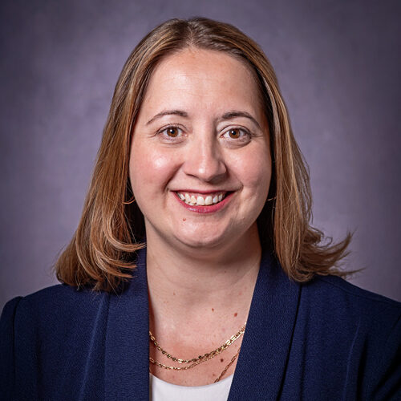
Jennifer Blickwedehl, Ph.D.
Chief Academic Officer
15+ Years at Trocaire
- Chief Academic Officer
  - Jun 2025 - Present
- Associate Dean of Curriculum and Instruction
  - Jan 2020 - Jul 2025
- Faculty Senate President
  - Aug 2014 - Jan 2020
- Professor of Biology
  - Aug 2010 - Jan 2020
Education
- University of Buffalo
  - Ph.D. Microbiology and Immunology, 2007
- Westminster College (PA)
  - BS Molecular Biology, 2001
Trocaire College Promotes Dr. Jennifer Blickwedehl to Chief Academic Affairs Officer"
June 30, 2025
Today, Trocaire College announced the promotion of Jennifer Blickwedehl, Ph.D. to chief academic affairs officer. She takes on the role from Richard Linn, Ph.D., who recently retired.
Connect with Dr. Blickwedehl on LinkedIn


Jason Konesco
Executive Vice President
“Trocaire College Names Jason T. Konesco Executive Vice President”
October 8, 2024
Today Trocaire College announced the appointment of Jason T. Konesco to executive vice president starting on Nov. 11. This is a newly created position at Trocaire following a national search…
Konesco will work closely with Dr. Deeb in pursuing and addressing key strategic efforts to ensure long term sustainability for the college. In his role, Konesco will administer the functions of workforce development, grants, business development for credit and non-credit offerings in collaboration with academic leadership and enrollment and enhance external community partnerships. In addition, Konesco will work in collaboration with members of the President’s Council to provide primary administrative leadership, direction, and evaluation for all activities of the college in addition to acting for the president in his absence as the college’s second ranking officer…
With more than 25 years of experience in education, Konesco most recently served as president, investor and board member of Perceivant, Inc., an interactive and educational software company that changes the way college students learn and instructors teach. He is also the former CEO and co-founder of ClearScholar, Inc. which was acquired by Civitas Learning in 2018. Prior to these leadership roles in educational technology companies, Konesco spent nearly 17 years in higher education as an administrator at Harrison College, including serving as president and CEO of this Indiana-based institution.
Konesco earned an MBA in finance from Butler University and a bachelor’s degree in marketing from the University of Notre Dame. He currently sits on two university boards – the Academy of Art University in San Francisco and the University of Advancing Technology in Tempe.
Connect with Jason Konesco on LinkedIn

Advancement
Trocaire does not have an advancement executive. Dianna Civello most recently held the role of Executive Director of Advancement at Trocaire in 2022. She is now in ED of Advancement at Canisius University.
Connect with Dianna Civello on LinkedIn

Student Body
- Total Enrollment: 1,069 (all undergraduate)
- Full time beginning undergraduate students receiving financial aid: 98%
  - Percent of students receiving federal grants: 81%
  - Percent of students receiving Pell grants: 81%
  - Percent of students receiving state/local government grants or scholarships: 79%
- Full-time beginning undergraduate students receiving student loan aid: 73%
- Retention rate for first time students pursuing bachelor’s degrees: Not Reported
- Overall graduation rate: 31%
- Full time students: 39%
- Student to Faculty Ratio: 9 to 1
- Student Demographics:
  - Women: 85%
  - Men: 15%
  - White: 48%
  - Black or African American: 34%
  - Hispanic/Latino: 6%
  - Asian: 5%
  - Race/ethnicity unknown: 5%
  - Two or more races: 1%
  - American Indian or Alaskan Native: 1%
  - U.S. Nonresident: 0%
  - Native Hawaiian or other Pacific Islander: 0%
- Eligibility
  - Title III Eligible (SIP)

Foundation Funding
Link to Foundation Funding History
Foundation Funding Total 2018-2025: $1,967,455 (51 awards) + $425,000 Mother Cabrini grant
“Trocaire College awarded $425,000 grant from Mother Cabrini Health Foundation to support Catholic education”
Jan 28, 2026
Trocaire College, a private, Catholic college providing a pathway for students to build careers of achievement and lives of purpose, was awarded a $425,000 grant from the Mother Cabrini Health Foundation to fund the Western New York Catholic Education Support Initiative. This two-year pilot program would be a collaborative effort to create a future where all Catholic learners have access to a supported, stable framework of services throughout their education.

Recent Award
Trocaire has been awarded one federal grant since ending their contract.
Agency, Office: Program |  | Start Date | Total Funding | Description
ED, OPE: TRIO SSS | 2025 |  | $272,400 | TRIO Student Support Services

Successful M&Q Projects
Total Wins: $8,893,927 (11 awards)
Agency, Office: Program |  | Start Date | Total Funding | Description
DOJ, OVW: Campus | 2022 |  | $299,168 | Grants to Reduce Domestic Violence, Dating Violence, Sexual Assault, and Stalking on Campus
NY State: Workforce Development Challenge | 2022 |  | $674,162 | New York State Grant, NY Strategic Workforce Development Office: Workforce Development Challenge
NSF, DUE: ATE | 2022 |  | $336,458 | A Cybersecurity Preparation Academy (C-PREP) for Buffalo Students and Teachers  Daniel Neville (Principal Investigator) nevilled@trocaire.edu  There is an acute need in the region for cybersecurity technicians since supply has not kept pace with the rapidly growing demand. The goal of this project is to create an educational pathway, in a high-poverty region, to produce cybersecurity technicians who can help address this workforce need. This will be accomplished by designing and implementing dual enrollment courses in two partnering high schools that will lead to matriculation in a postsecondary cybersecurity program. Upon graduation students will have earned either a postsecondary certificate or an AAS degree in cybersecurity qualifying them for employment as technicians in the cybersecurity field.
ED: Title III SIP | 2021 |  | $2,128,218 | TrocAres: Trocaire College Active Response and Engagement System
NEH: Humanities Initiatives at Community Colleges | 2020 |  | $132,291 | Community and mission: Building a new applied ethics minor at Trocaire College.
James H Cummings Foundation | 2020 |  | $24,190 | Foundation Application
ED: TRIO SSS | 2020 |  | $1,309,440 | Trio Student Support Services
NY State, Education Department: HEOP | 2019 |  | $1,820,000 | New York State, NY Department of Education: Higher Education Opportunity Program (HEOP)
DOJ, OVW: Campus | 2018 |  | $300,000 | Trocaire College's program to reduce domestic violence, dating violence, sexual assault, and stalking.
James H Cummings Foundation | 2018 |  | $70,000 | Foundation Application
HHS: Nursing Workforce Diversity | 2017 |  | $1,800,000 | Nursing workforce diversity

Congressionally Directed Funding
Sen. Chuck Schumer (D-NY) and Sen. Kirsten Gillibrand (D-NY) represent Trocaire College. Both participate in the earmarks process. Neither have secured earmarks on behalf of Trocaire College.
Trocaire submitted earmark requests to both Senators in FY24 and FY25. Each request was for $950k for a nursing education simulation lab and purchasing simulation equipment. None of them were funded.
Rep. Timothy Kennedy (D-NY-26) represents Trocaire College. He participates in the earmarks process but has not secured any earmarks for Trocaire College.
Rep. Nicholas Langworthy (R-NY-23) also represents Trocaire’s Extension Center. He participates in the earmarks process but has not secured any earmarks for Trocaire College.
Trocaire has an extension campus just over the district border:
Main Campus
360 Choate Avenue
Buffalo, NY 14220
Extension Center Trocaire Achievement Complex
6681 Transit Road
Williamsville, NY 14221

Grants Office
Trocaire does not have a grants office.

Academic Programs

- Allied Health and Professions Division
  - Diagnostic Medical Sonography
  - Echocardiography
  - Healthcare Management Program
  - Management Program
  - Massage Therapy
  - Medical Assisting
  - Radiologic Technology
  - Surgical Technology
- Technology Professions
  - Cybersecurity
  - Data Analytics
  - Healthcare Informatics
- The Catherine McAuley School of Nursing
  - Nursing
- Veterinary Sciences
  - Veterinary Technology
- Division of Arts and Sciences
  - Biology
  - General Studies
- Workforce Development
  - ChatGPT 101
  - CPR/BLS for Health Care Providers
  - Critical Skills Leadership Development
  - Customer Service Programs
  - EKG Technician
  - Financial Health and Education
  - Healthcare Customer Service
  - Healthcare Programs at Gerard Place
  - IT Training
  - Pharmacy Technician Program
  - Phlebotomy
  - Sterile Processing & Distribution Program
  - Veterinary Assistant Program

Recent News
Trocaire College President Appointed Commissioner with Middle States Commission on Higher Education
January 20, 2026
Dr. Deeb joins the Commission from January 1, 2026, to December 31, 2026, to fill an expired term. He has served as a peer evaluator for the Commission since 2012.
The Middle States Commission on Higher Education (MSCHE) is a global institutional accreditor recognized by the United States Secretary of Education since 1952. As an accreditor and member of the regulatory triad, MSCHE assures students and the public of the educational quality for its over 500 institutions of higher education.

Trocaire College Launches Professional Certification in Generative AI Foundations
November 7, 2025
For professionals seeking entry-level certification in AI tools, Trocaire College, a private, Catholic college providing a pathway for students to build careers of achievement and lives of purpose, today announced the launch of its ChatGPT 101 Professional Certification in Generative AI Foundations.

